**Client Requirements Questions**

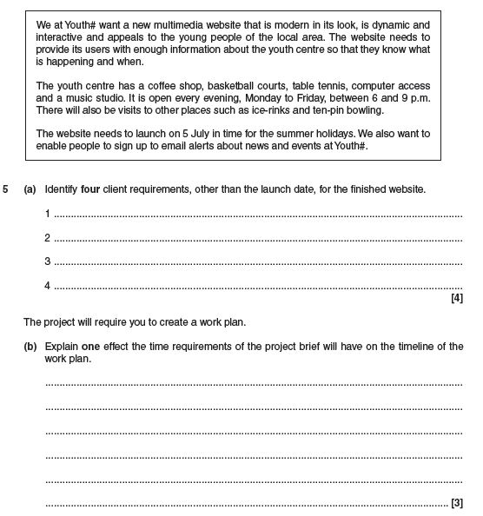

1.

Identify **four** client requirements, other than the launch date, for the finished website.

1. It must be dynamic.
2. It must appeal to young people in the club’s area.
3. It must contain information about the club’s facilities and dates.
4. It must launch on the 5th of July.

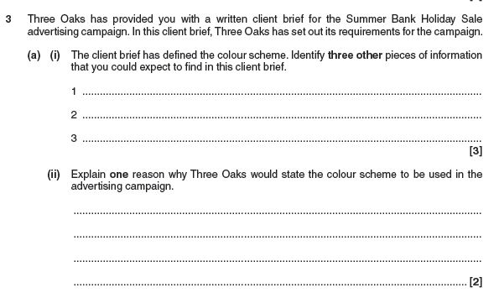

2.

a) The client brief has defined the colour scheme. Identify **three** other pieces of information that you could expect to find in this client brief.

I could expect to find the target audience, the due date, and the content for the website.

b) Explain **one** reason why Three Oaks would state the colour scheme to be used in the advertising campaign.

Three Oaks could have stated the colour scheme to be used in the advertising campaign to help keep a consistent image for their brand. For example, the colour green could be associated with Three Oaks, so they may have included that in their colour scheme to make their content more recognisable.

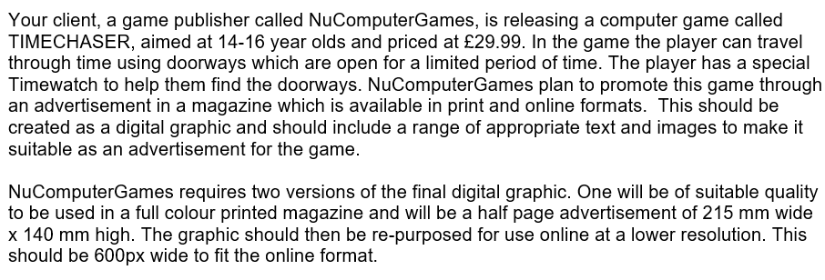

3.

|  |  |
| --- | --- |
| What are you creating? | An advertisement for a computer game called TIMECHASER. |
| What is the purpose of the product? |  |
| What content should be included? |  |
| Specification (sizes, file types, formats, info to include etc) |  |
| What style/genre should you use? |  |
| Who is the target audience? | 14-16 year olds. |

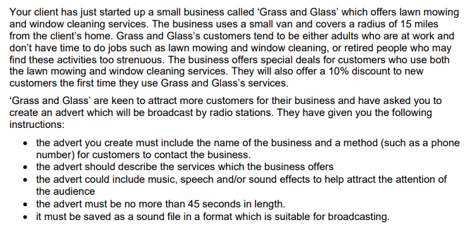4.

|  |  |
| --- | --- |
| What are you creating? |  |
| What is the purpose of the product? |  |
| What content should be included? |  |
| Specification (sizes, file types, formats, info to include etc) |  |
| What style/genre should you use? |  |
| Who is the target audience? |  |

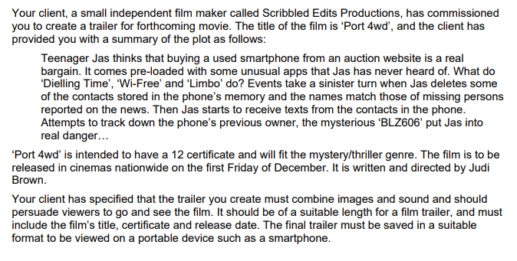

5.

|  |  |
| --- | --- |
| What are you creating? |  |
| What is the purpose of the product? |  |
| What content should be included? |  |
| Specification (sizes, file types, formats, info to include etc) |  |
| What style/genre should you use? |  |
| Who is the target audience? |  |

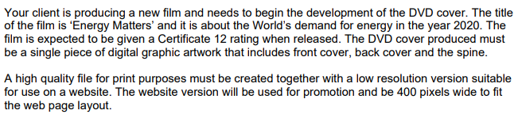

6.

|  |  |
| --- | --- |
| What are you creating? |  |
| What is the purpose of the product? |  |
| What content should be included? |  |
| Specification (sizes, file types, formats, info to include etc) |  |
| What style/genre should you use? |  |
| Who is the target audience? |  |